WPF TCP Client Application –

1 – Overview & Purpose
Overview
This application is a TCP Client built using C# and WPF (Windows Presentation Foundation). It allows users to:
- Connect to a server using IP and port.
- Send and receive messages in real-time.
- Maintain a log of all messages in a text file (ClientLog.txt).
Purpose
- Learn the basics of TCP/IP networking in C#.
- Understand client-server communication.
- Gain experience with WPF UI design.
- Keep logs for message tracking and debugging.
How It Works
- User selects a server IP and port.
- Connects to the server.
- Sends messages to the server.
- Receives messages asynchronously.
- Logs all activity to a file and on-screen chat window.

2 – Key Features
1. Connection Management
- Select IP and port from ComboBoxes.
- Connect to the server with a button click.
- Disconnect automatically if the server closes or manually when needed.
2. Messaging
- Type messages in the message TextBox.
- Send messages to the server.
- Receive messages from the server in real-time.
- Display all messages in a chat-like window (txtChat).
3. Logging
- All messages are saved in ClientLog.txt.
- Logs include timestamps (automatic by appending in real-time).
- Open logs in Notepad for review.
- Clear logs to start fresh.
4. File Handling
• Select file using Select File button
• Supports CSV file format
• Fetch and display CSV data in table/grid
• Refresh CSV data when needed
• Clear table data
5. SQL Table Integration
• Select SQL table from dropdown (cmbSqlTables)
• Fetch SQL table data
• Display data in grid/table
• Refresh table data
• Clear table contents
6. Data Control Features
• Refresh Button → Reloads latest data (CSV/SQL)
• Clear Table Button → Clears displayed data
• Helps manage and reset data view easily
7. WPF UI Features
- ComboBoxes for selecting IP and Port.
- TextBox for typing messages.
- Chat window displays all communication.
- DataGrid/Table for CSV and SQL data
- Buttons for:
  - Connect
  - Send
  - Open Log
  - Clear Log
  - Select File
  - Fetch CSV
  - Refresh
  - Clear Table
  - Fetch SQL

3️⃣ How the Application Works (Step-by-Step )

✅ Step 1 – Start Server
• Open Server application
• Click Start Server
• Server starts listening on a port (e.g., 5000)
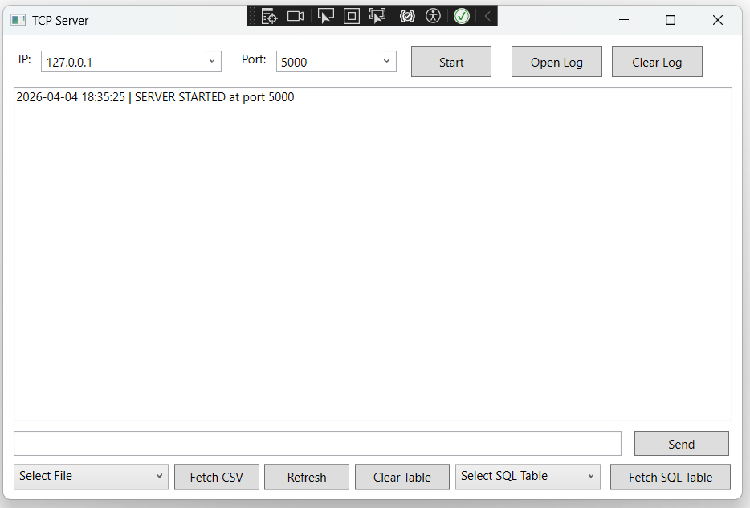

✅ Step 2 – Start Client Application
• Open Client application
• IP addresses are loaded automatically
• 127.0.0.1 is added

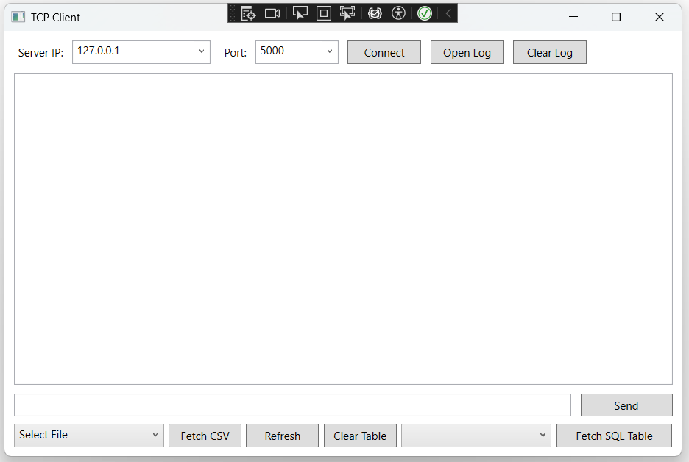

✅ Step 3 – Connect Client to Server
• Select IP and Port
• Click Connect
Then:
• Client connects to server
• Server accepts connection
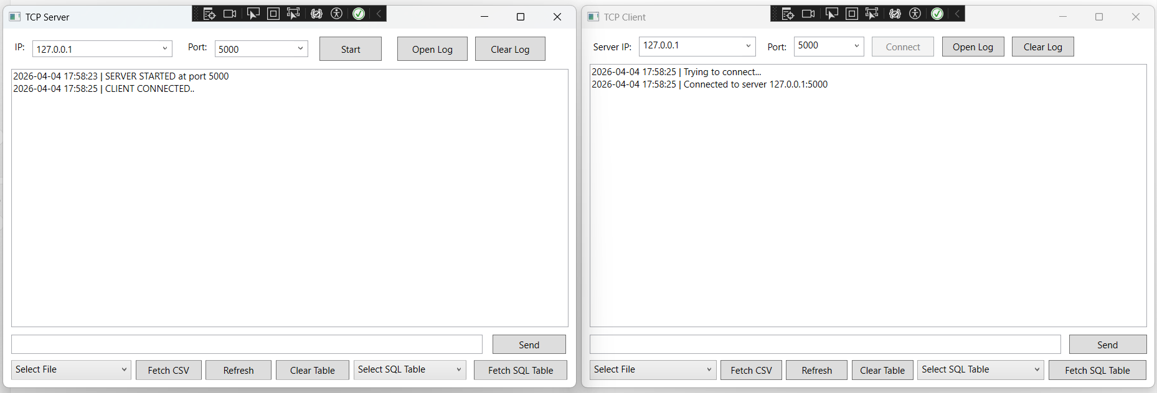

✅ Step 4 – Send Message (Client → Server)
• Type message in client
• Click Send
Then:
• Message sent to server
• Displayed in client chat
• Server receives and logs it
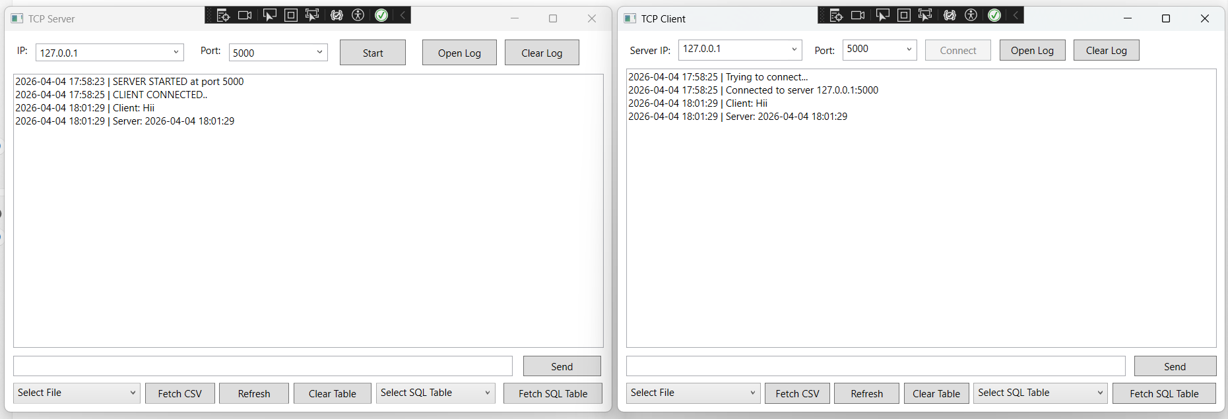

✅ Step 5 – Receive Message (Server → Client)
• Server sends response
Then:
• Client receives message instantly
• Displayed in chat window

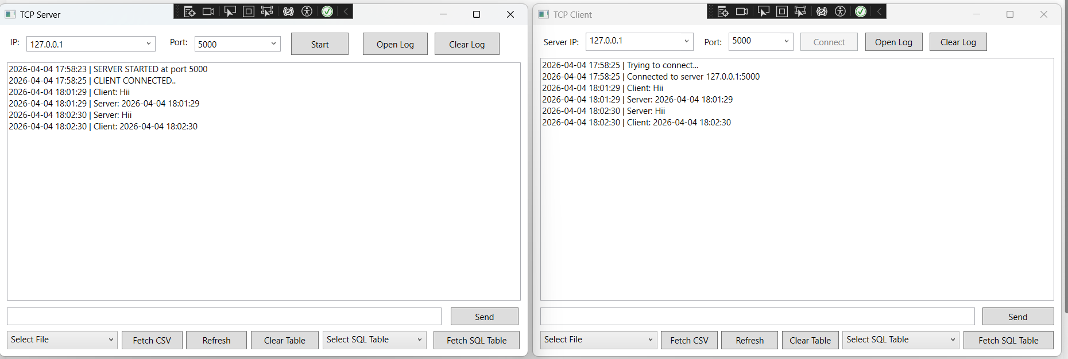

✅ Step 6 – CSV File Handling ( Both Side)
• Click Select File
• Choose CSV file
• Click Fetch CSV
Then:
• Data displayed in table
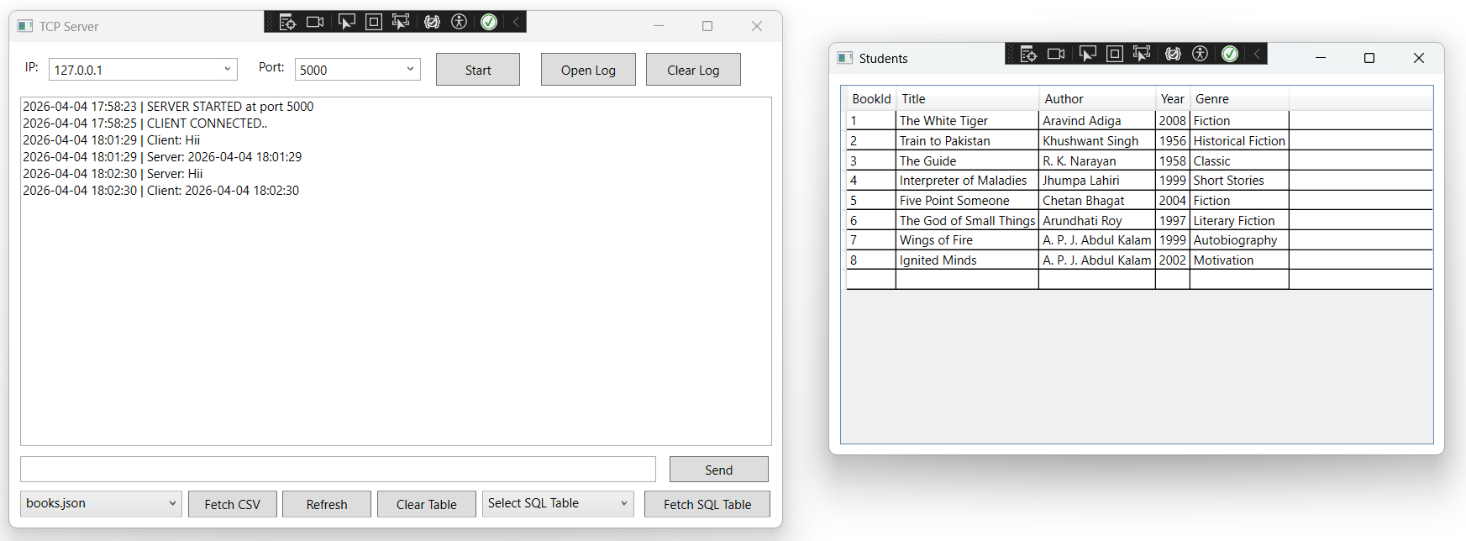

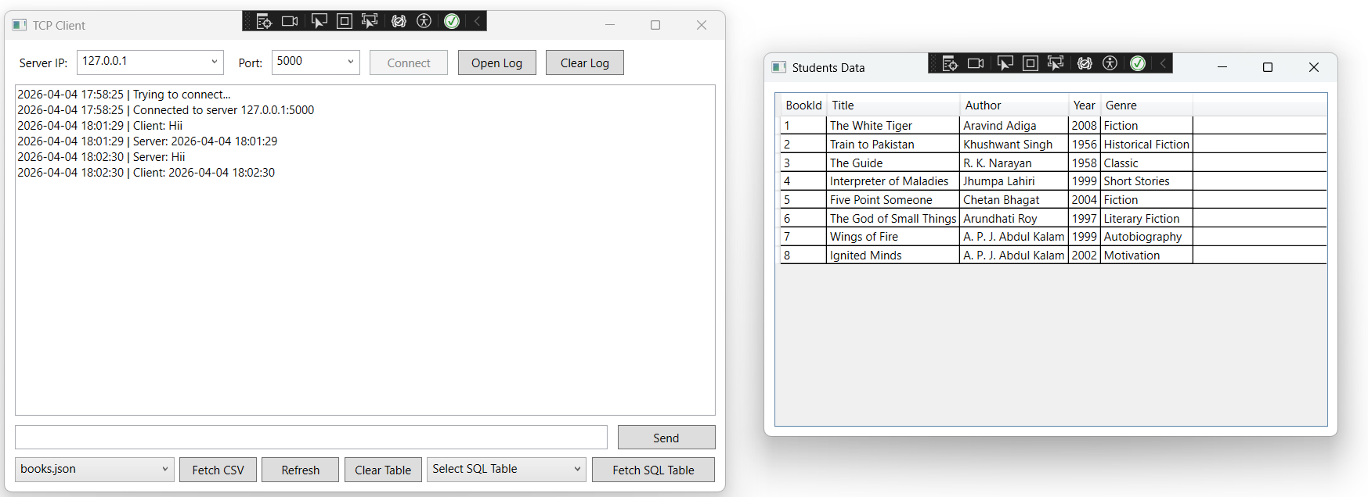

✅ Step 7 – SQL Table Fetch (Client / Server)
• Select SQL table from dropdown
• Click Fetch Table
Then:
• Data loaded and displayed

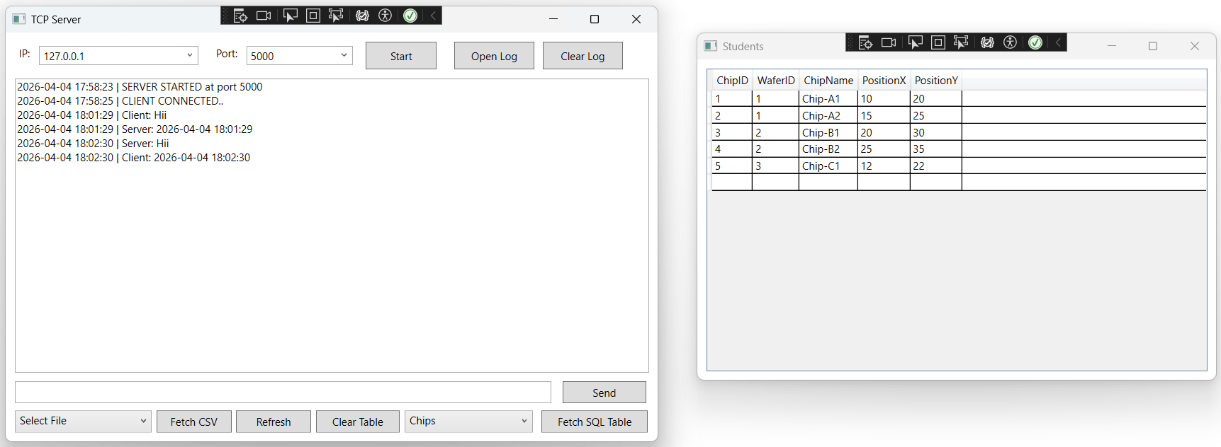

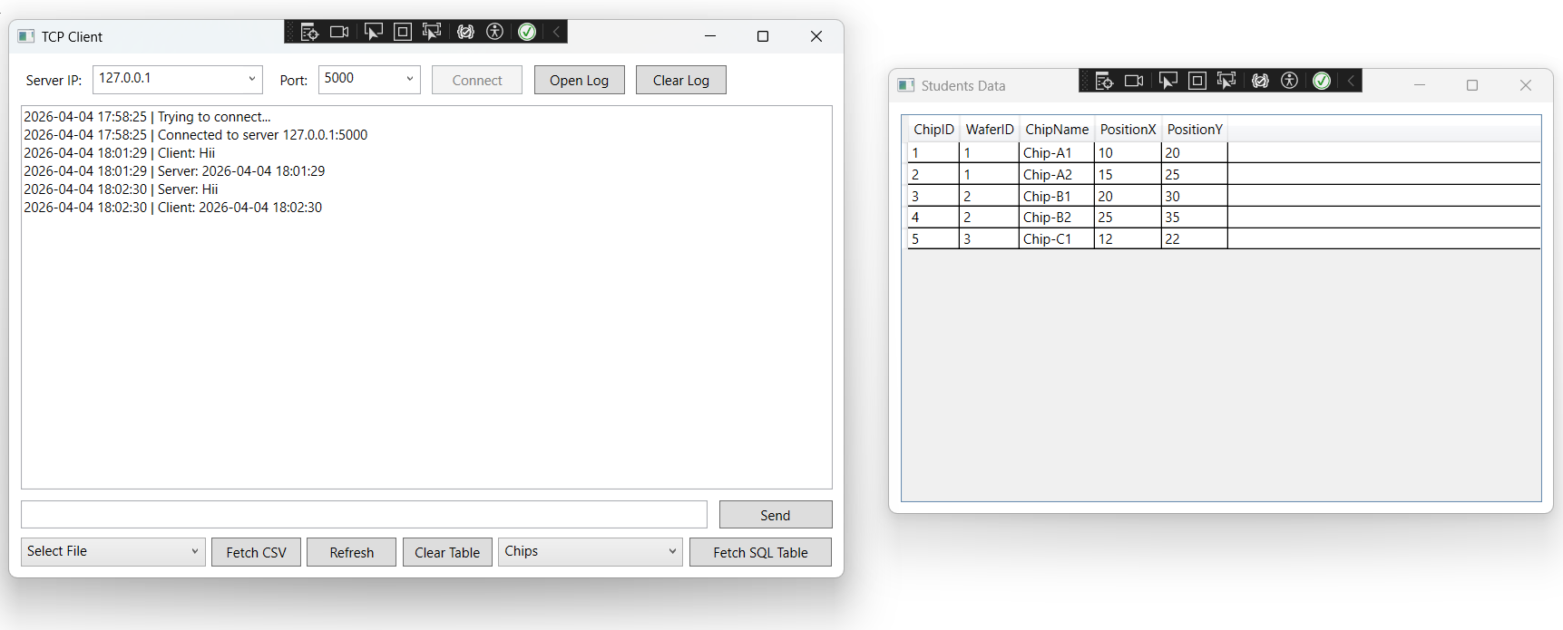

✅ Step 8 – Refresh & Clear Data
• Refresh → reload data
• Clear → removes data


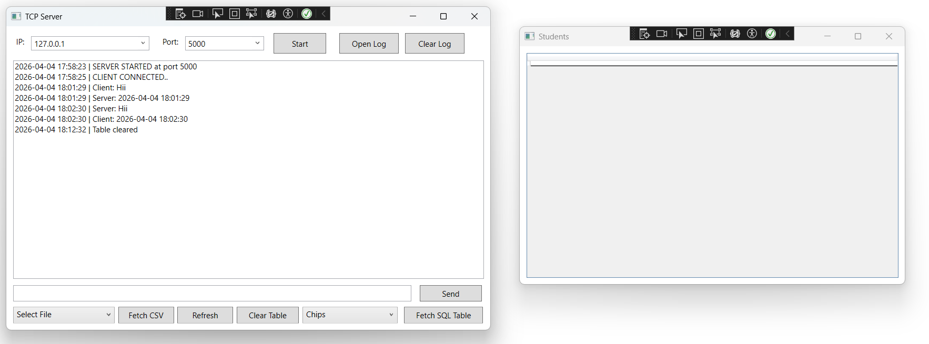

✅ Step 9 – Logging
• Client logs → ClientLog.txt
• Server logs → ServerLog_2026-03-30_00-23.txt
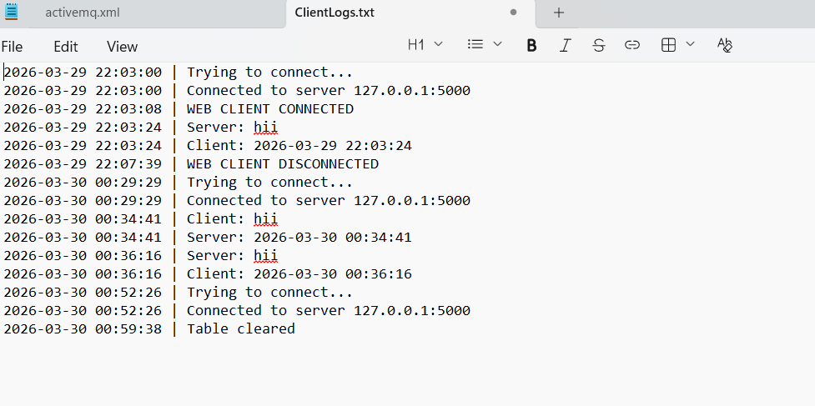

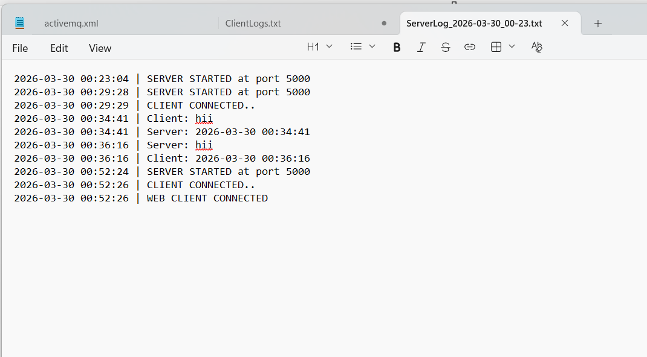

✅ Step 10 – Web Client Connection (If Used)
• Web UI connects using WebSocket
• Server logs this event
• When the Web UI connects, the message WEB CLIENT CONNECTED should be displayed in both the application window.
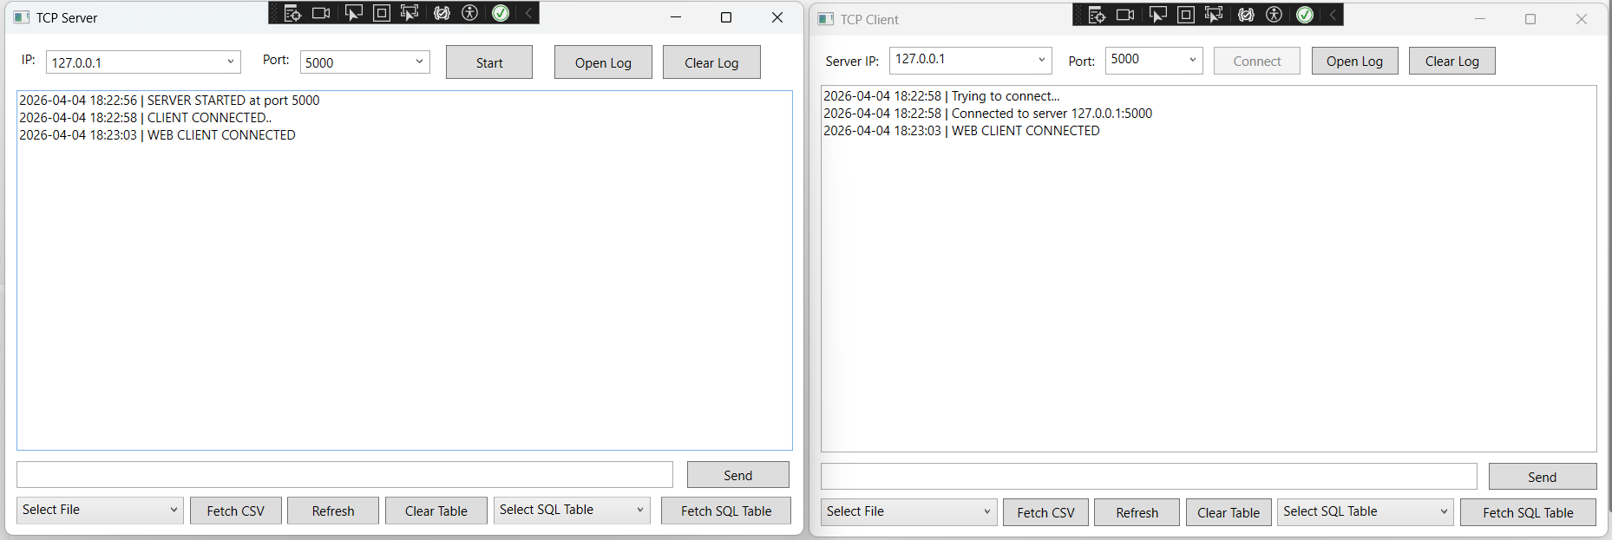

✅ Step 11 – Disconnect
If:
• User disconnects OR
• Server stops
Then:
• Connection closes safely
• Logs updated
• When the Web UI disconnects, the message WEB CLIENT DISCONNECTED should be displayed in both the application.
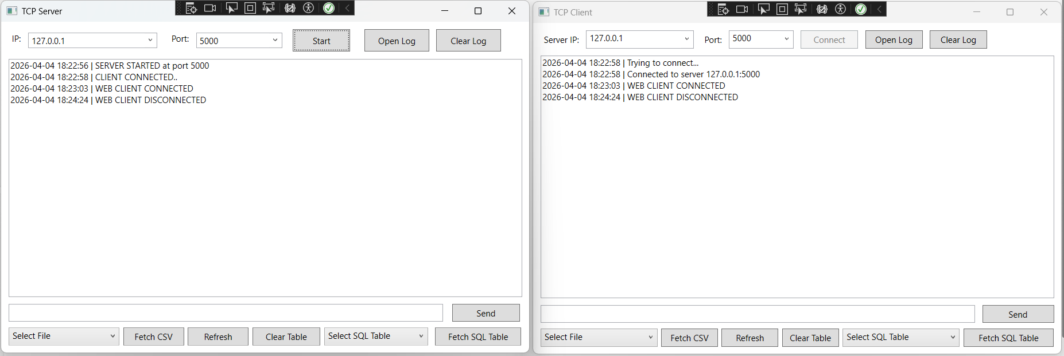

2️⃣ WebSocket Connection Setup
SyncBridge uses WebSocket protocol to establish real-time communication between the web interface and backend server.
WebSocket enables:
• Two-way communication (Client ↔ Server)
• Instant message transfer
• No page refresh required
• Continuous live connection

🔎 How It Works Technically
- Browser sends WebSocket request.
- Server validates request.
- Connection upgrades to WebSocket.
- Server connects internally to TCP Server.
- Messages flow:
Web Page ↔ WebSocket ↔ TCP Server

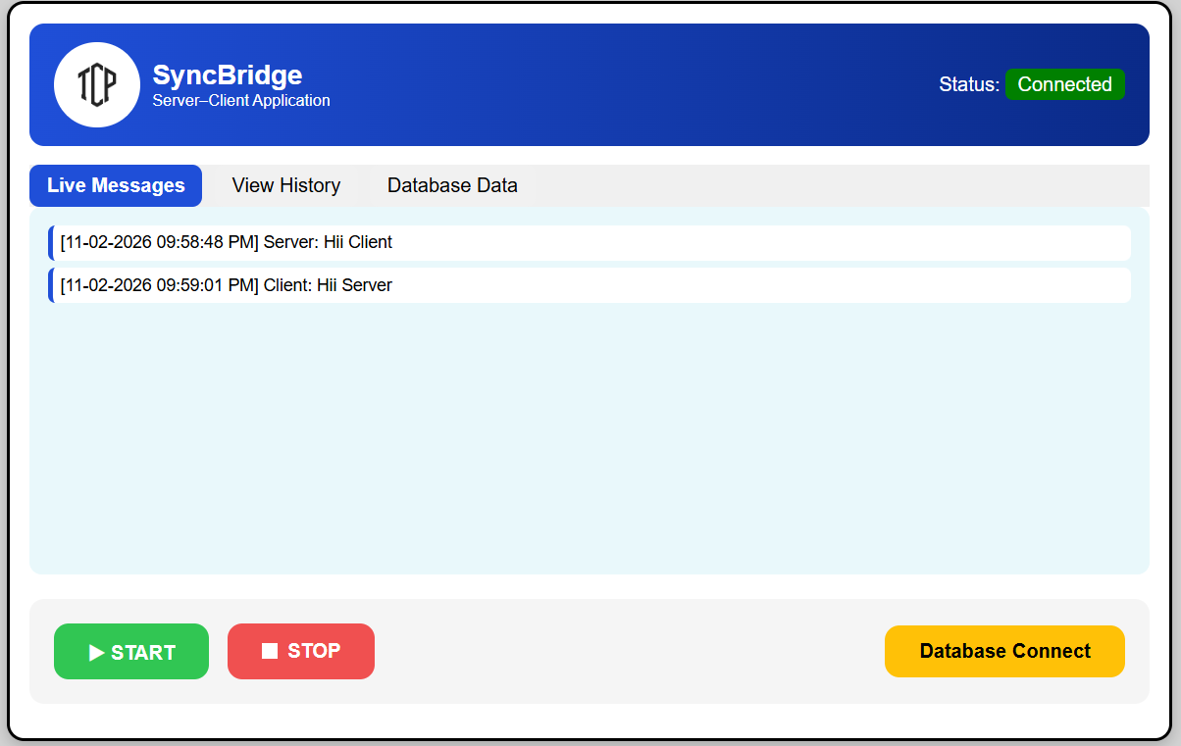

📘 SyncBridge –

1️⃣ Application Launch
Step Description:
When the application starts, the main dashboard loads with:
- Application title (SyncBridge)
- Status indicator
- Tabs (Live Messages, View History, Database Data)
- Start and Stop buttons

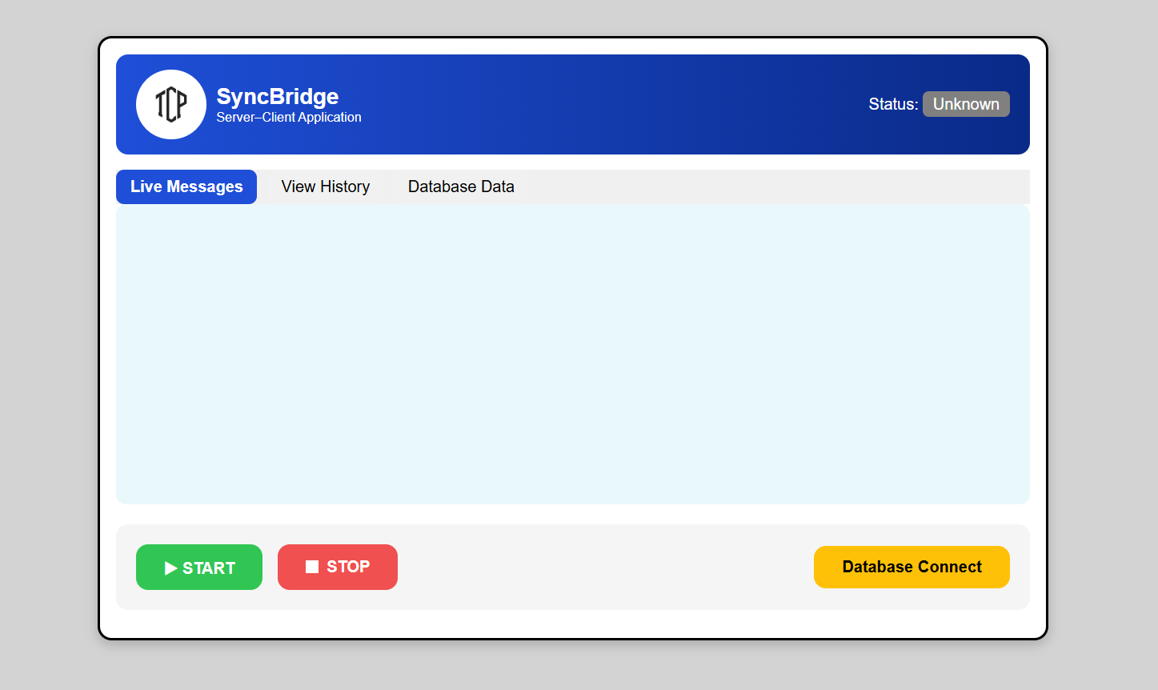

🔹 Step 1: Live Messages Tab
The Live Messages tab displays real-time communication between the server and client.
It shows:
- Server Started
- Client Connected
- Client Messages
- Server Messages
- Messages with Date & Time
🔁 Message Reply Logic (No Infinite Loop Condition)
✔ When the client sends a message to the server:
→ The server replies with the current date and time.
✔ When the server sends a message to the client:
→ The client replies with the current date and time.
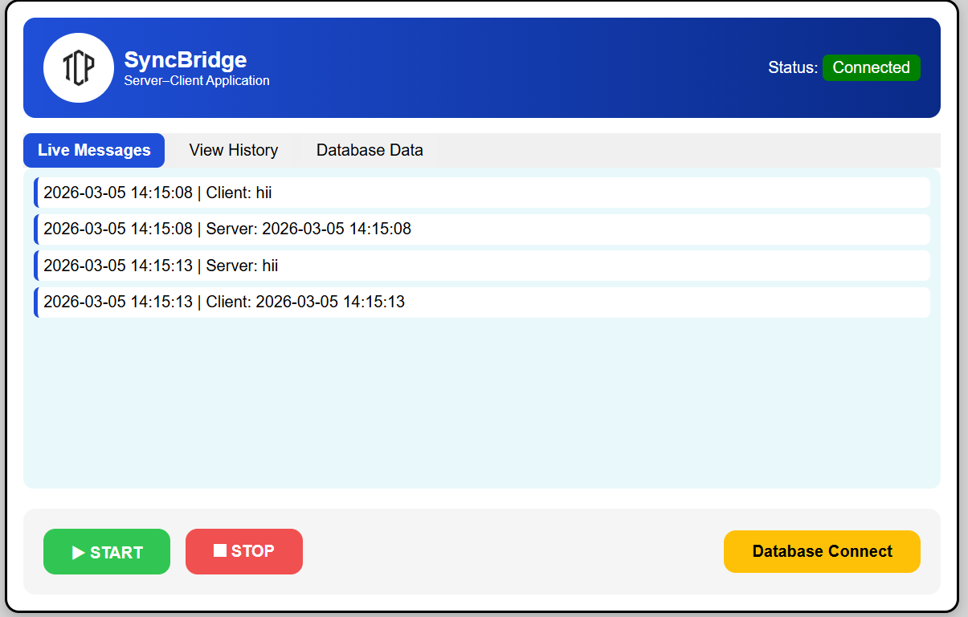

🔹 Step 2: View History Tab
The View History tab allows users to see previously saved conversations between the server and client.

🧭 Steps to View History
1️⃣ Click on the Three Lines (Menu Icon)
- Click the ☰ (menu icon) on the top left.
- The History Panel will open.
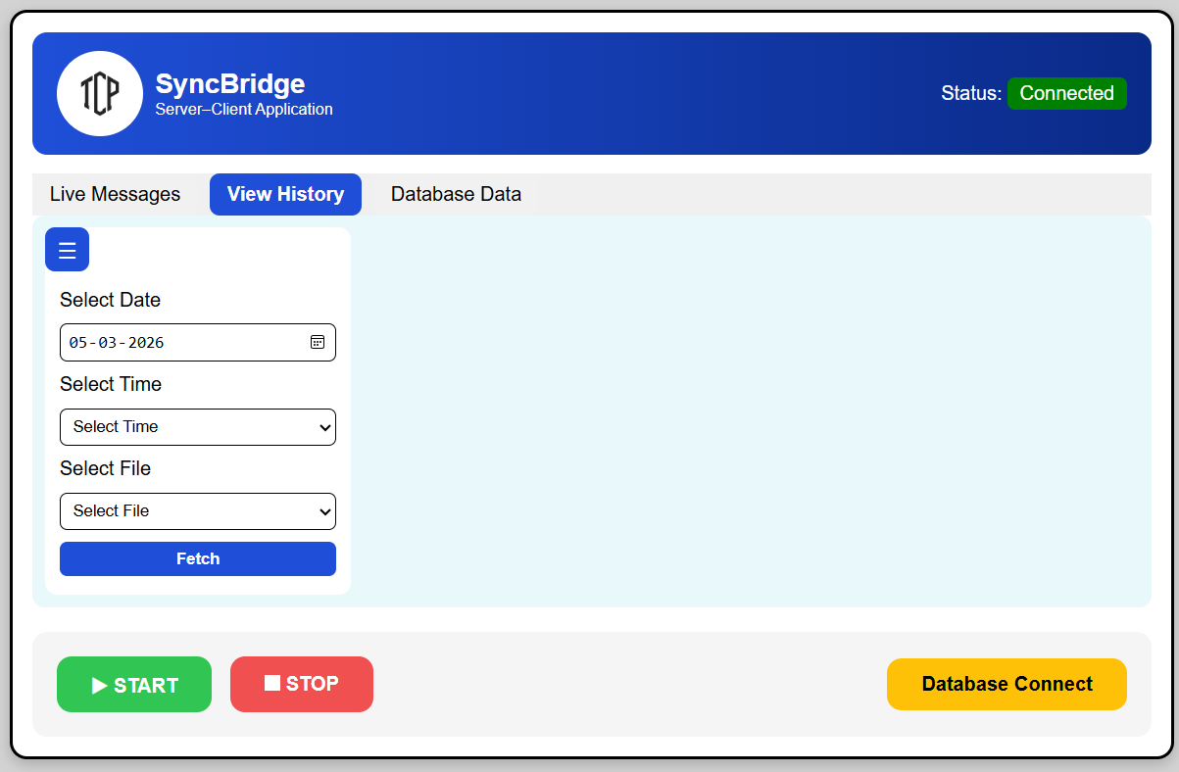

2️⃣ Select Date
- Choose a date from the Select Date calendar input.
- After selecting a date:
  - The system sends a request to the server.
  - The Select Time dropdown will automatically display:
    - The creation times of log files for that selected date.
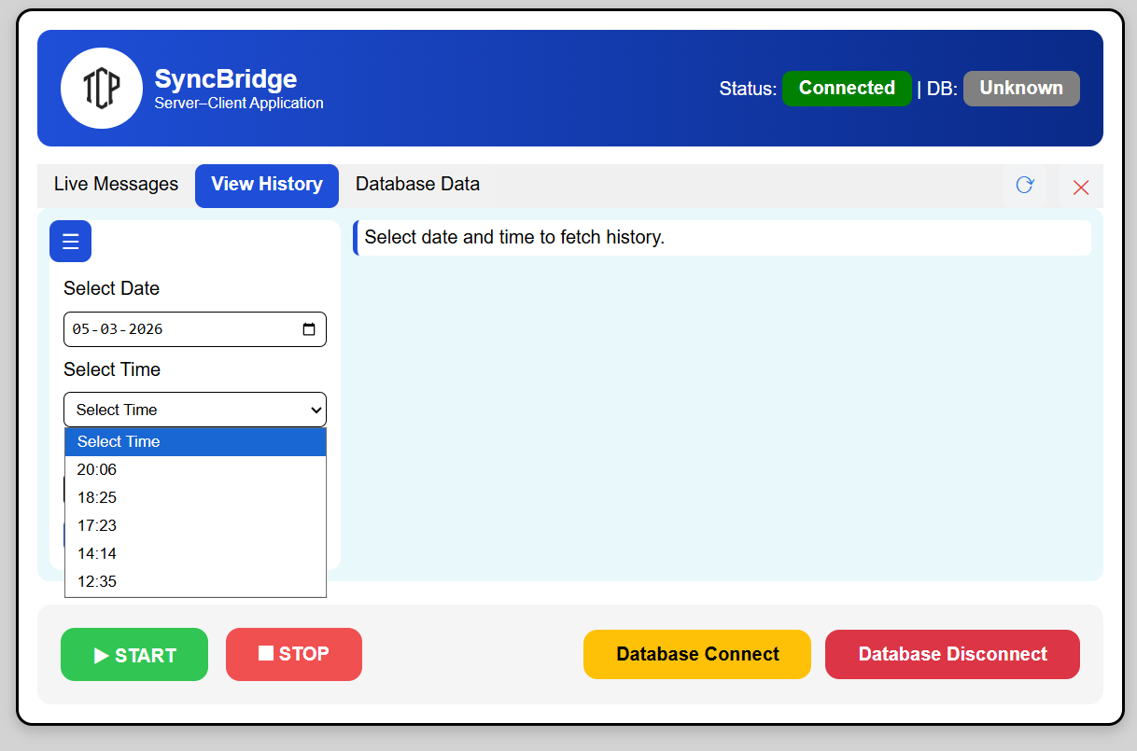

3️⃣ Select Time
- Choose a time from the Select Time dropdown
- After selecting a time:
  - The matching file for the selected date and time will be automatically displayed by name only
  - No dropdown box is shown; only the file name is displayed

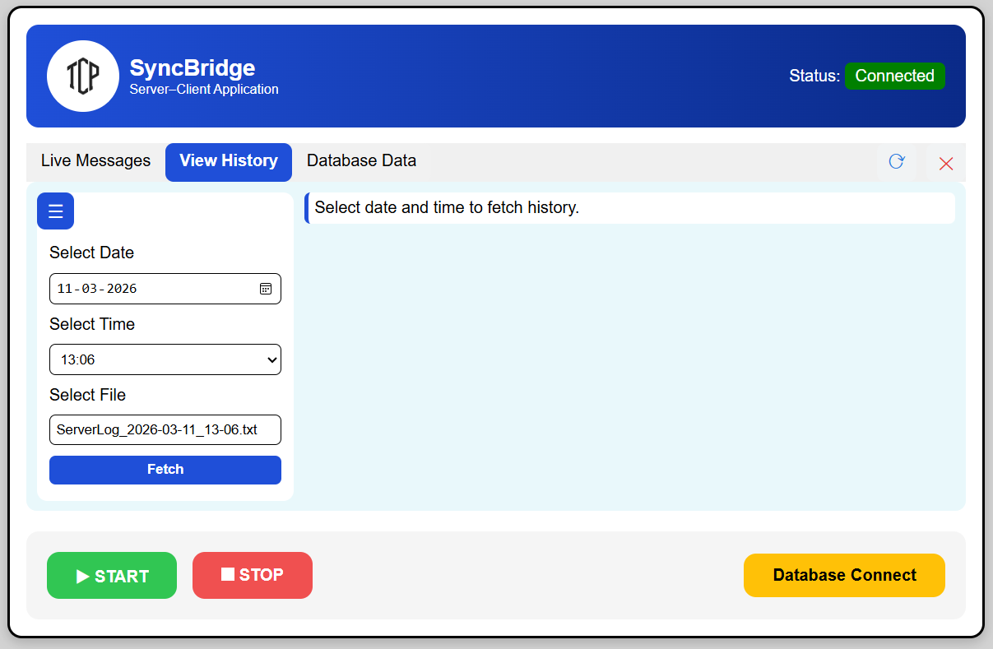

4️⃣ Click on the Fetch Button
- Click the Fetch button.
- The system sends a request to retrieve the selected log file.📄 After Clicking Fetch
✔ If file exists:
- All logs from the selected file will be displayed
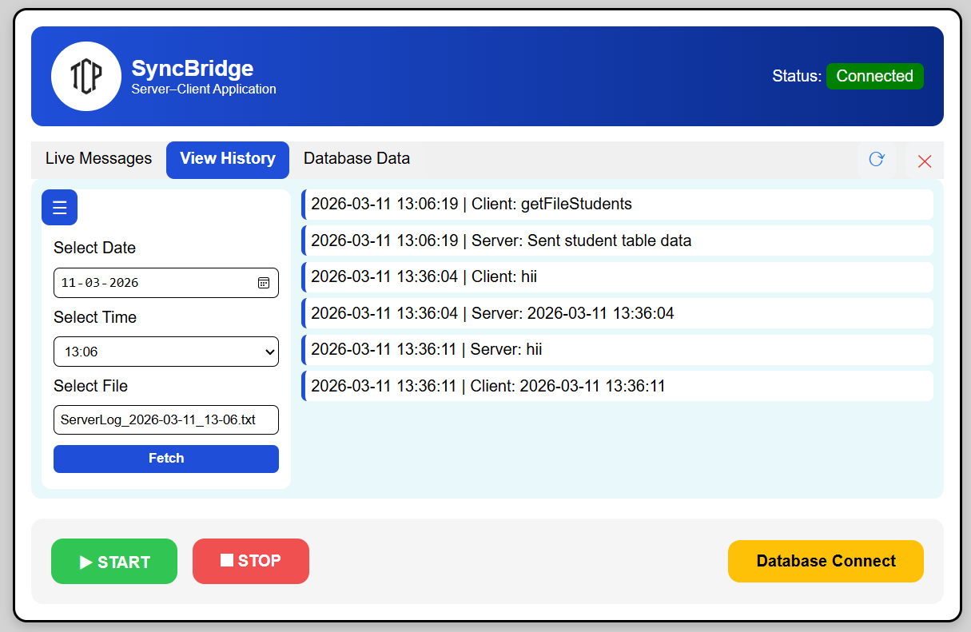
- Inside the View History tab message area

🔹 Step 3: Database Data Tab

🔹 Step 1: Create a CSV File for Student Data
Steps:
- Open a text editor or Excel
- Create a file named students.csv
- Add the following data:
Sno | Name | Age | College
1 | Shubham | 23 | AMGOI
2 | Sushant | 22 | SGM
- Save the file in the project folder:
C:/SyncBridge/Data/students.csv

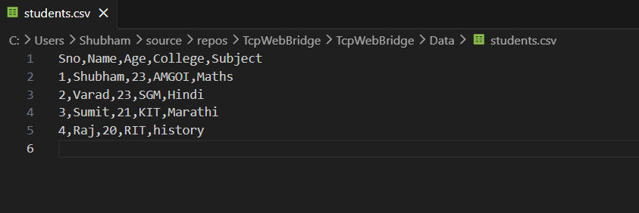

🔹 Step 2: Open Database Tab in Web UI
Steps:
- Open the SyncBridge Web UI
- Click on the Database Data Tab

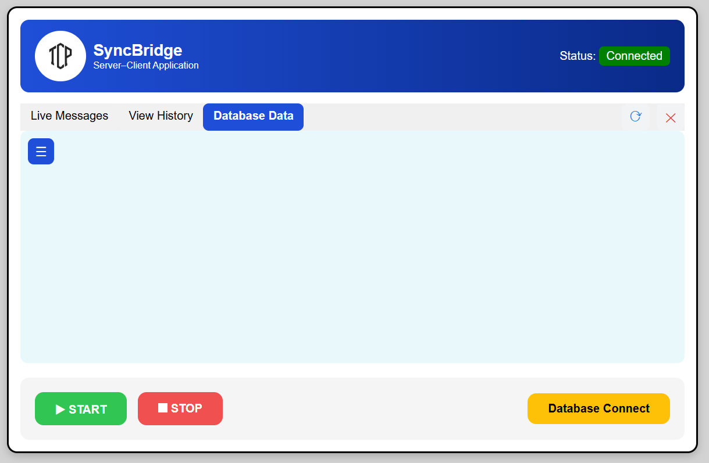

🔹 Step 3: Open Menu and Select File
Steps:
- Click on the ☰ (Menu Icon)
- The Database Panel will open
- A Select File dropdown will be displayed
- The dropdown will show all files available in the folder

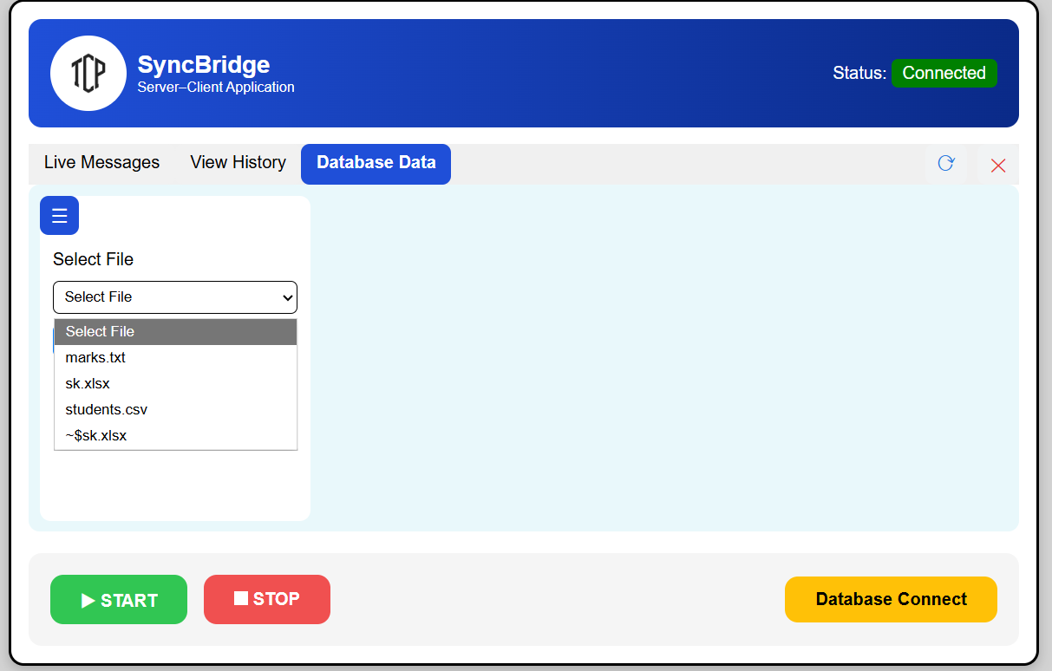

🔹 Step 4: Select File and Fetch Data
Steps:
- Select a file from the dropdown
- Click on Fetch File Data button

📄 System Message:
Data has been fetched successfully

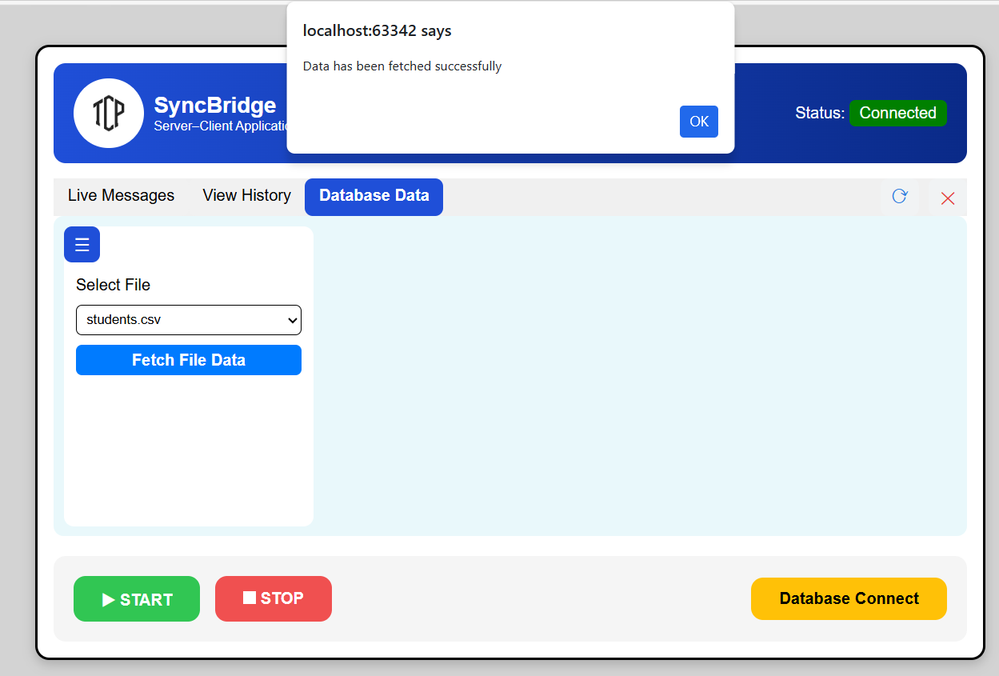

🔹 Step 5: Display Data in Table
Result:
- Selected file data will be displayed in the table
- Table headers are created dynamically
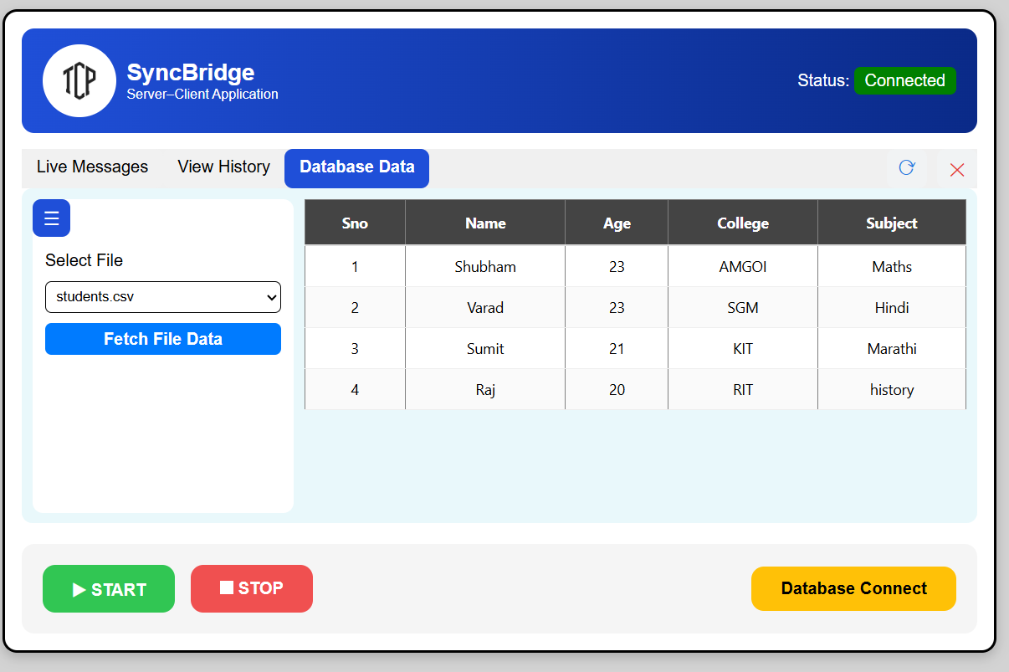
- Data is shown in structured format

🔹 Step 6: Auto Update Feature
- If the file is updated in the folder:
  - Web UI will reflect changes after clicking Refresh (⟳)
  - No need to reload the full application

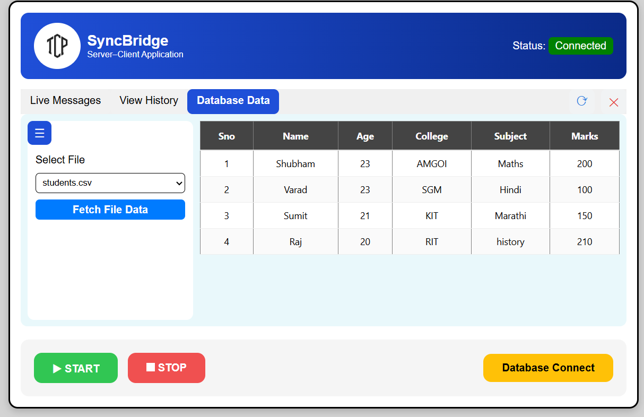

🔹 Step 9: Multiple File Type Support
Supported File Types:
- .csv
- .txt
- .json
- .log
- All supported files will be shown in the dropdown list

🔹 Step 4: SQL Database Connectivity
🧭 Step 1: Open Database Popup
- Click the “Database Connect” button.
- The database modal popup will appear.
- Ensure the database connection is successful.

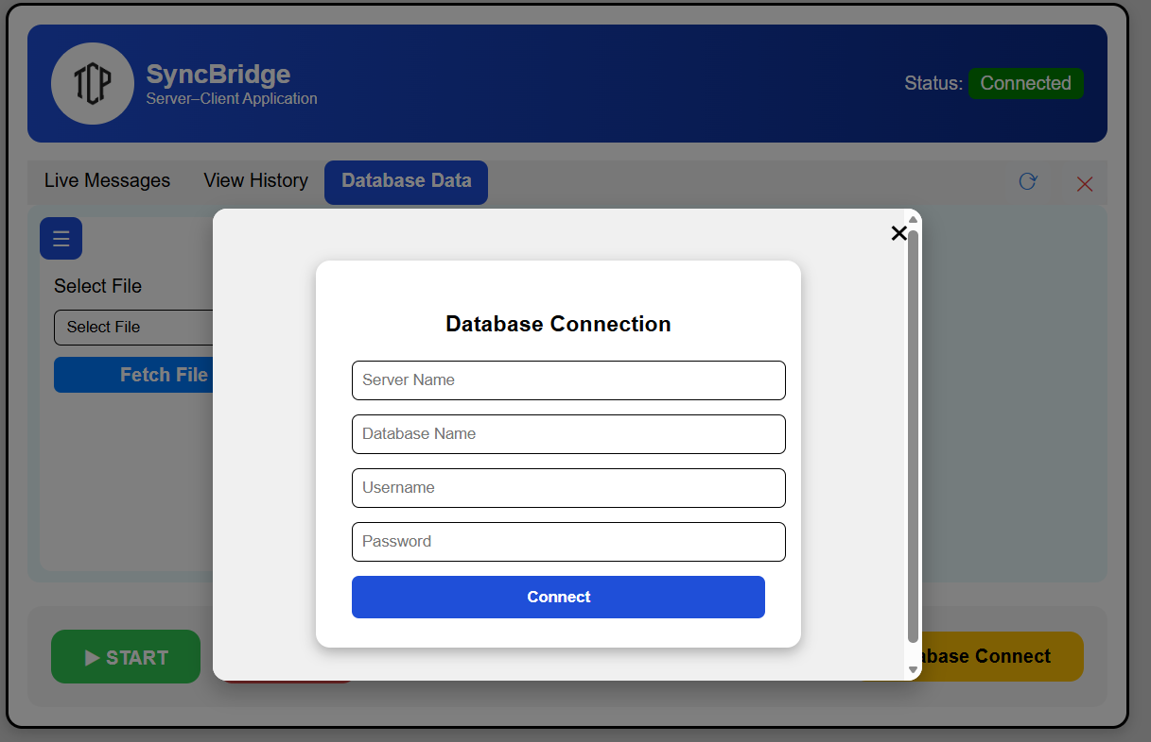

🧭 Step 2: Enter Details
- Server Name
- Database Name
- Authentication Type
- Username/Password

🧭 Step 3: Connect
✔ Status becomes Green
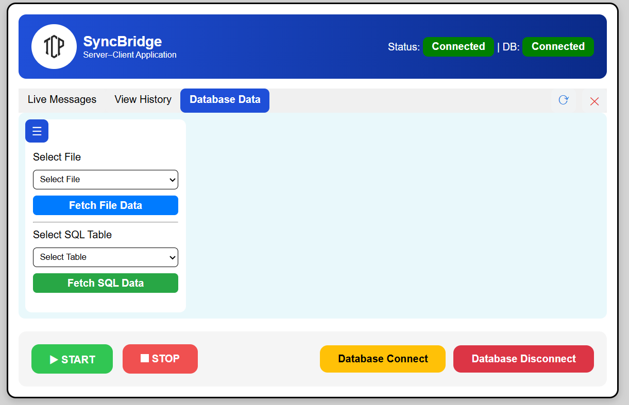

🧭 Step 4:SQL Table Operations

🧱 Create Table
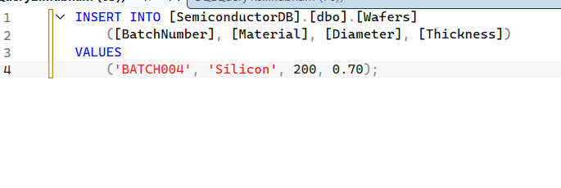
Example-:
🧭 Step 4: Fetch SQL Data
Steps:
- Select SQL Table
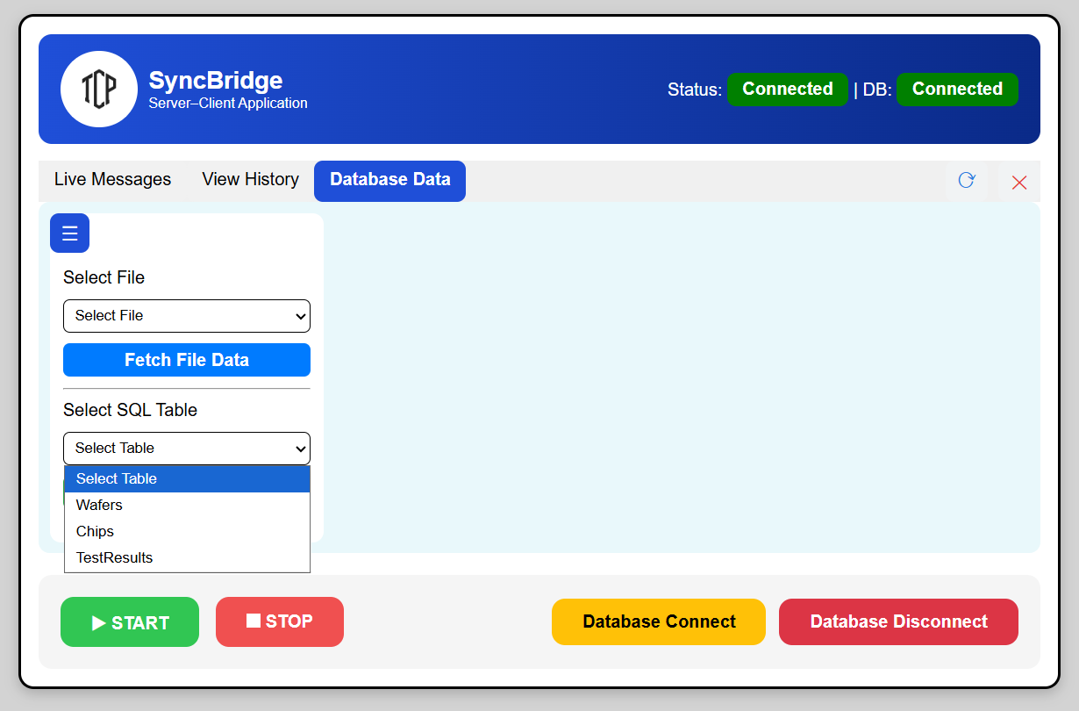
- Click Fetch SQL Data

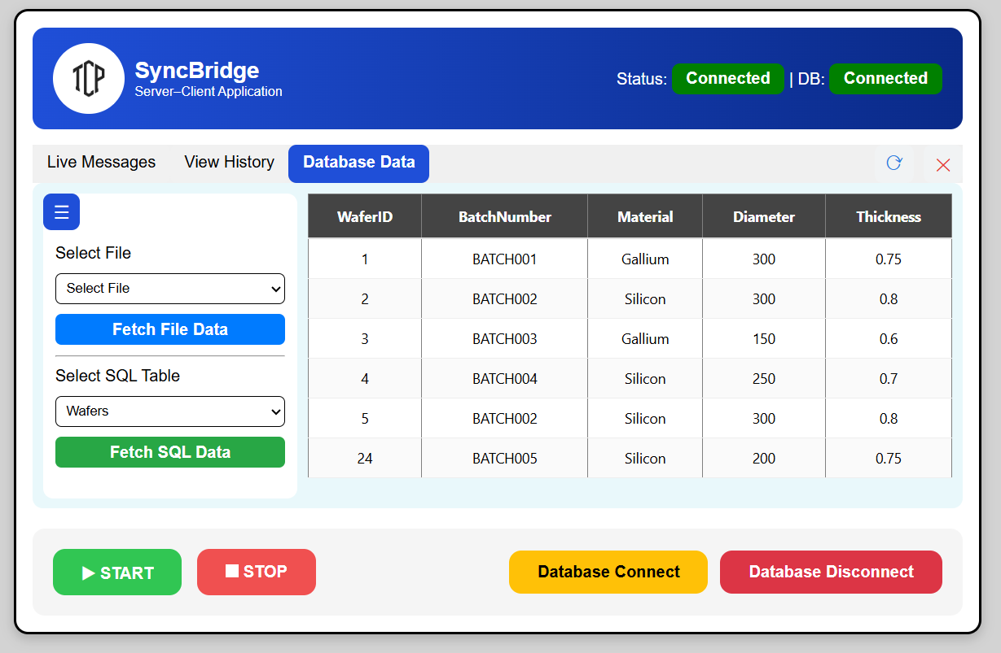

🧭 Step 5: Database Disconnect
- Click Database Disconnect
- Confirm action

📄 Result:
- DB Status → Red
- SQL operations disabled
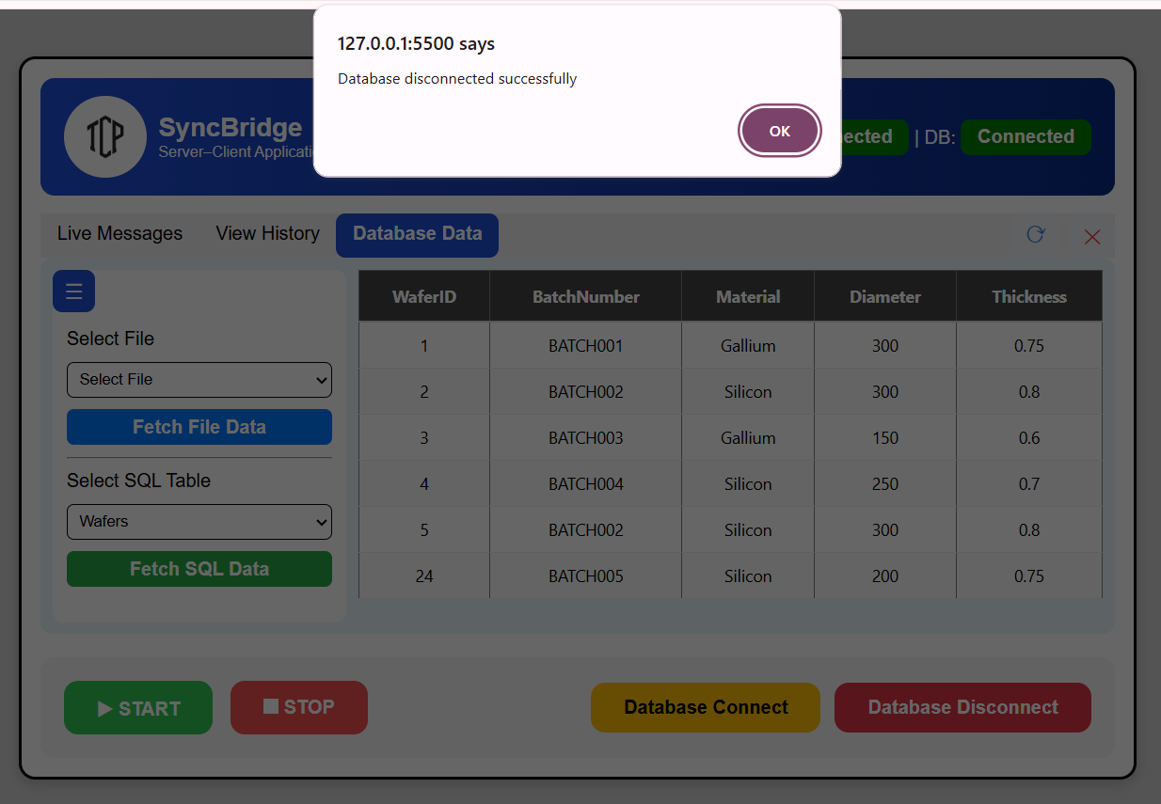

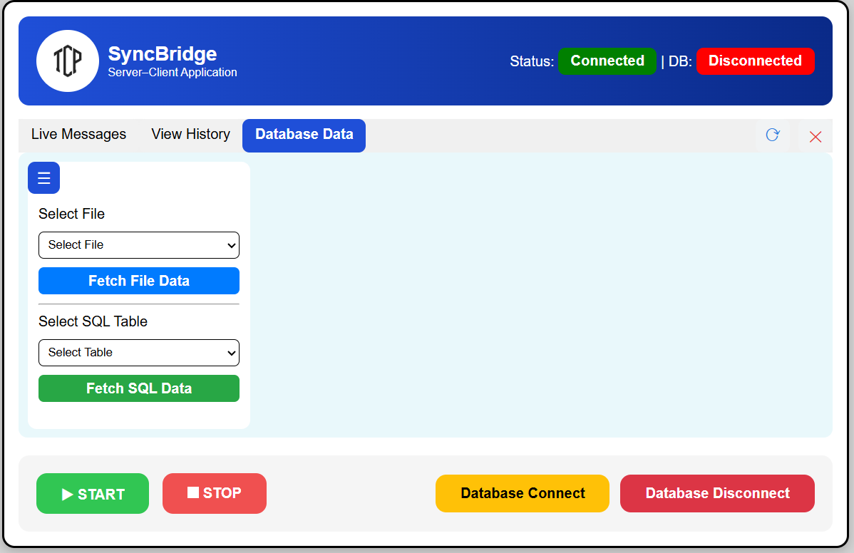

- Refresh Feature (⟳)

🧭 Function:
- Reloads data in current tab
✔ Live → reload logs
✔ History → reload selected file
✔ Database → reload file/SQL data
Refresh
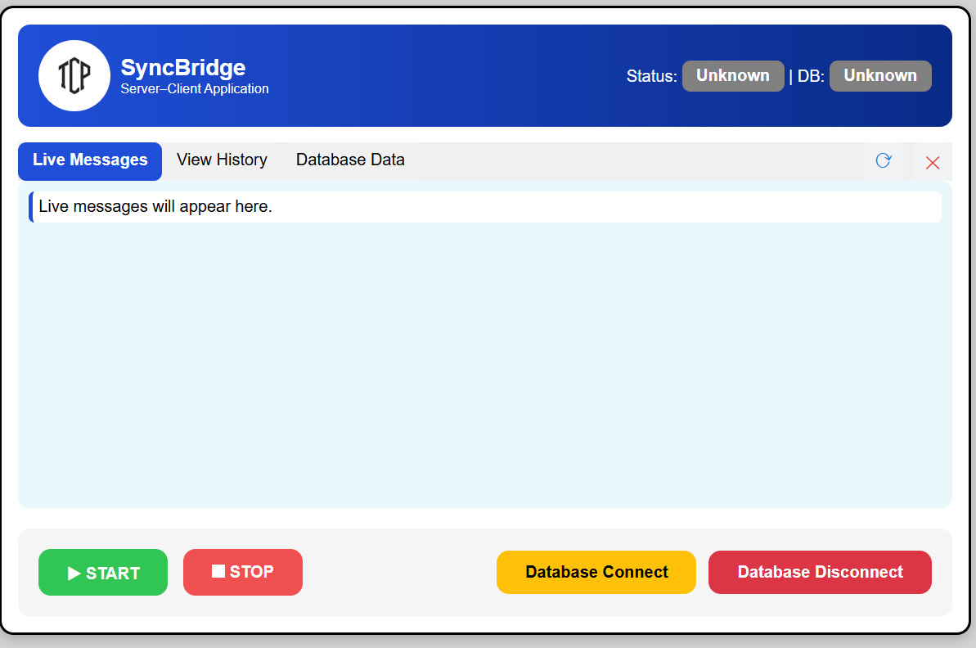

- Clear Feature (✕)

🧭 Steps:
- Click Clear
- Confirm dialog

📄 Result:
- Data cleared from current tab
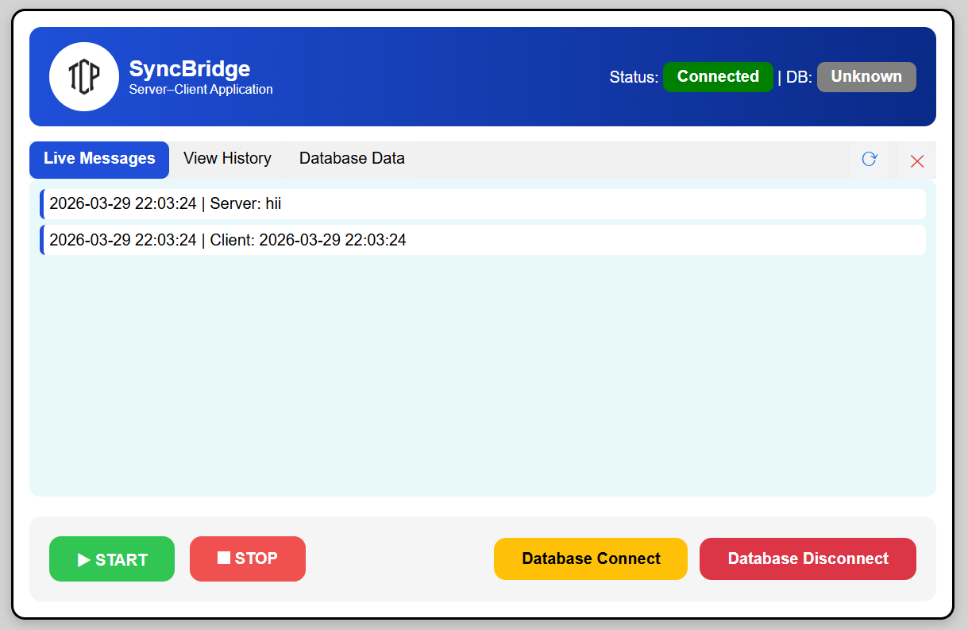

Clear Button

